GUI Documentation

DlgEdit – This is the editor that allows you to create GUIs for the game. Right click the on the window to bring up the Menu Properties dialog. Here’s a description of the fields:

- Menu Name: The name of the menu that you will reference it by in the game.
- Motion Direction: This is the direction that the menu will appear from when toggled in the game. Choices are NONE (Default), FROM_TOP, FROM_BOTTOM, FROM_LEFT, and FROM_RIGHT.
- Time: This is the amount of time the menu takes to appear or disappear when toggled.
- General Commands: You can add any of the appropriate layout commands mentioned below.

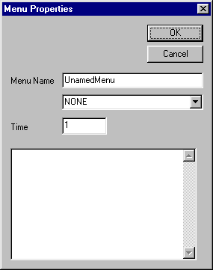
General Commands go here

To create a widget, just click the LMB anywhere in the background and drag out a region. This will define the frame of the widget. Double click in the frame of that widget to bring up the Widget Properties Dialog. Here’s a description of the fields:
- Name - Internal name of the widget. This really isn’t used much in the game and was added (just in case we need it).
- Class - Defines the class of the widget (Button, Label, List, etc…).
- Title – Title to be displayed for labels, buttons, etc..
- Cmd – Stuff command to be put into the command buffer when the widget is activated (i.e. button is pressed).
- Cvar – Name of the cvar to link this widget with. If the value of the widget changes, then this cvar will be updated with the appropriate value.
- Border – Style of the border of the widget.
- BGColor – Background color of the widget.
- BGAlpha – Background alpha of the widget.
- FGColor – Foreground color of the widget.
- FGAlpha – Foreground alpha of the widget.
- Position – Position of the widget ( x,y,width,height).
- Class specific attributes – Extra information that applies to the widget. See the list of layout commands below.

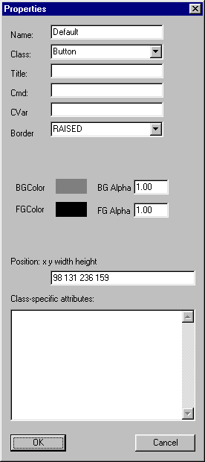

Layout commands
align <left> <right> <top> <bottom> | Aligns the widget to the specified directions (resolution independent)
shader <shadername> | Sets the shader of the widget. This will be drawn stretched in the widget
tileshader <shadername> | Sets the shader of the widget. This will be drawn tiled in the widget
hovershader <shadername> | Sets the shader that will be drawn when the mouse is hovering over the widget
additem <item> | Adds the specified item to a list or listbox widget
setrange <min> <max> | Sets the range of the slider from min to max
direction <from_left | from_right | from_top | from_bottom> | Sets the direction of the shader when it appears on the screen. It will scroll in from that direction over time
slidertype <integer | float> | Sets the type of the slider to either integral or floating value
fadein <time> | Makes the widget fade in over the specified time
stopsound <soundname> | Plays the sound specified when the widget stops moving
clicksound <soundname> | Plays the sound specified when the widget is clicked
stretch < horizontal | vertical > | Stretch the widget horizontally or vertically across the whole screen (resolution independent )
initdata <data> | Initializes the widget to data (used for sliders)
sliderstep <stepsize> | Sets the stepsize for the slider

